Society of Women Engineers (SWE)

SWE Definition
The Society of Women Engineers is a student organization at Milwaukee School of Engineering, as well as an international society. SWE is open to anyone interested in promoting females in engineering, including females and males, engineers and non-engineers.

SWE’s Mission
The mission of SWE is to stimulate women to achieve full potential in careers as engineers and leaders, expand the image of the engineering profession as a positive force in improving the quality of life, and demonstrate the value of diversity.

MSOE SWE’s Mission
At MSOE, we focus on developing students professionally by providing various opportunities to network, improve professional skills, and actively promote engineering careers to young girls interested in STEM-related fields.

Objective
SWE’s objective is to obtain funding for MSOE SWE officers to attend SWE’s National Conference, WE19, in Anaheim, California on November, 7-9, 2019.

My Narrative
The ability to bring the whole team to the national conference is very important to me as the president. Last year, I began the year holding the outreach position and had the tremendous honor of attending WE18 in Minneapolis, Minnesota. The experience was a great benefit to me because of the people I met, both at the largest career fair for women and at the numerous networking, technical, and outreach breakout sessions. I not only got to learn about the changing engineering technologies like sustainable street lighting in urban environments and engineering better products through lifecycle thinking, but I also became better equipped for my position as an officer on the SWE executive board. For example, I attended a session about growing the next generation of engineers through partnerships with SWE & Girl Scouts and a SWE Outreach Committee Open Discussion. There I got new ideas for how to get general members more involved. Another big aspect of the conference is the career fair and networking, which was one of the biggest advantages of attending the conference. I met many individuals from different collegiate and professional sections from around the nation as well as company recruiters at the career fair that exposed me to a broader range of possibilities that even MSOE’s Annual Career Fair does not offer. I applied all that I learned from the national conference into my vision for outreach last year. I created a better, rounded outreach committee and delegated more of the responsibility to the general members to get them involved. I proposed a partnership with the local Girl Scout troops in the Milwaukee area and the officer group discussed new ideas about how to rearrange and improve the structure of leadership and volunteering system that we have in our Section. So, this experience not only advanced my innovation and leadership skills as an officer of SWE, it also promoted my professional career as well through the many networking and job opportunities I brought back to Milwaukee and used to get internship opportunity for the coming summer.

Breakdown
The ability for SWE’s officers to attend the national conference is important to our section. In the past, we have allocated the funds from sponsors to four officers to attend national conference because we were awarded enough funding for only four officers to fly to the conference. This past year, since WE18 was so close (Minneapolis, Minnesota), our officer board of eight women decided to drive and share two hotel rooms. This way we could bring our whole officer board, and everyone could benefit from the entire experience. This year we are looking to find a new source of funding, so that this years SWE officers will be able to take advantage of the SWE National Conference. The cost breakdown of WE18 expenses is shown below in Figure 1. We used most of our funding on this trip and we are so thankful to have received it.

 |  | Total
Conference | Registration | $700.00
 | Celebrate SWE | $360.00
 | Total | $1,060.00
Travel | Hotel | $1,944.72
 | Parking | $198.00
 | Gas | $235.54
 | Uber/Lyft | $202.37
 | Total | $2,580.63
Food | Dinner 1 | $115.54
 | Dinner 2 | $24.12
 | Dinner 3 | $29.76
 | Total | $169.42
Total Spent |  | $3,810.05
Figure 1: Cost Breakdown of Funding WE18

Attendance of the national conference is necessary for the entire officer board to have a deep understanding of what SWE is and how “you” can make a difference in any officer position. I went to sessions relating to outreach, but there are breakout sessions for the Treasurer, Fundraising, Webmaster, and Professional Development too. So, every officer will benefit from going to WE19 and will take away skills and knowledge that will help them improve as SWE officers, professional engineers, and as members of the MSOE community. Therefore, SWE is requesting $5,500 this year for attendance, travel and stay for the WE19 National Conference this year. I have made an estimated cost breakdown of the WE19 spending in Figure 2. Because the National Conference is in California, we would need to fly. Airfare right now is about $300 per person. And including the same fares for registration and hotel costs the total comes to about $5,500. I plan on heading the trip planning with the vice president, Morgan Balog, this year. I plan on purchasing plane tickets and hotel rooms as soon as possible to get the lowest rates which will hopefully cut down on costs. Also, driving to O’Hare with the officer’s own cars will bring down the cost of airline tickets.

 |  | Total
Conference | Registration | $700.00
 | Celebrate SWE | $360.00
 | Total | $1,060.00
Travel | Hotel | $2,000.00
 | Flight | $2,400.00
 | Total | $4,400.00
Total Spent |  | $5,460.00
Figure 2: Estimated Cost Breakdown WE19

I do understand that SWE is asking for a lot of funding, but any donation is greatly appreciated. This donation does not just go to the National Conference, MSOE SWE used any leftover money for Section’s events, such as Mr. MSOE in Spring Quarter. Also, this past year and in future years any extra funding goes to registration, stay, and travel to WELocal, SWE’s regional conferences, which is in Des Moines, Iowa this year. The regional conference is a mini version of We19 and MSOE SWE promotes this conference to MSOE SWE members and non-members. Additionally, we have started work on an Advocacy initiative and we are currently developing an annual 0.5 walk with the MSOE community. A benefit for your company to sponsor us is that you will get a fantastic selection of young engineers looking for summer internships, as well as jobs. Also, your company will have an option to come to our general meetings and do a company presentation. There are many possible benefits to partnering with MSOE SWE and those are just a few, including tax benefit for your company and a free registration to our Annual Career Fair Networking Dinner on September 25th, 2019. When you invest in SWE, you are not just paying for a trip for young engineering students. You are paying for an empowering experience for eight young women to bring knowledge back to MSOE, Milwaukee, and your company.

MSOE SWE is thankful every year for our supporters in empowering women in engineering and we hope to continue your support through this funding. As well as have the potential to make this a continuous partnership so that future SWE officers can benefit from the amazing conference.

Thank you, from the bottom of my heart.

Kathryn Ashley
MSOE SWE Section President -FY20
(847)-757-2848
ashleykr@msoe.edu

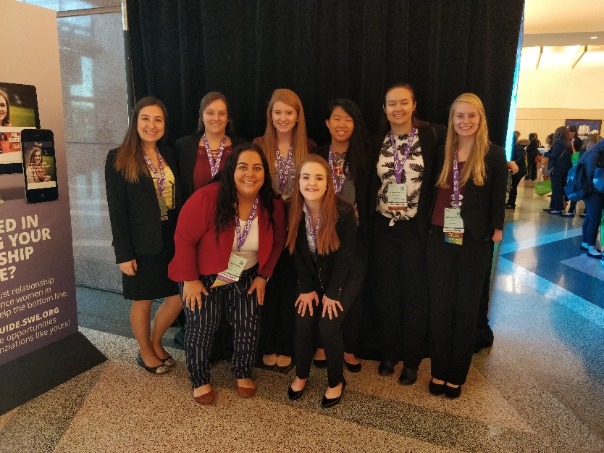

MSOE SWE Social Media Outlets:
Wordpress: https://swemsoe.wordpress.com/
Facebook: @MSOE SWE https://www.facebook.com/MSOESWE/
Instagram: @MSOE_SWE
Slack: msoeswe.slack

